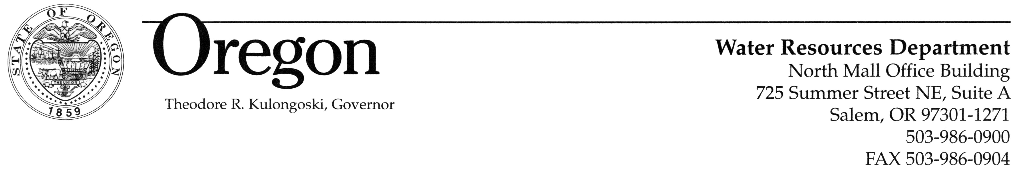
MEMORANDUM

TO: Water Resources Commission

FROM: Phillip C. Ward, Director

SUBJECT: Agenda Item E, August 30, 2007
Water Resources Commission Meeting

Public Interest Review of Application G-16773, Boyd Gatfield and Application G-16775, James and Marjorie Shelley

I. Issue Statement

The Umatilla Basin Program (OAR Chapter 690, Division 507) requires the Commission to review and consider the public interest for certain ground water uses within a five-mile radius of a municipal well for cities with a conservation program. The Cities of Hermiston and Milton-Freewater (OAR 690-507-0070(3)(d)(D) and OAR 690-507-0030(3)(a)(B), respectively) are implementing conservation programs. The Department has two pending applications for ground water uses that fall within these rule requirements: Application G-16773 within a five-mile radius of the City of Milton-Freewater’s wells; and Application G-16775 within a five-mile radius of the City of Hermiston’s wells. In order for the use to be consistent with the Umatilla Basin Program, the Commission is asked to review and consider the public interest for these applications.

II. Background

Under OAR 690-507-0030(3)(a)(B), the Commission must review and consider the public interest for water right applications for uses other than municipal, group domestic and statutorily exempt ground water uses from basalt wells within a five-mile radius of a municipal well of the City of Milton-Freewater (Attachment 1). Under OAR 690-507-0070(3)(d)(D), the Commission must review and consider the public interest for certain ground water uses within a five-mile radius of a municipal well of the City of Hermiston (Attachment 2). The Commission may permit additional uses if 1) there is a documented barrier to ground water movement between a proposed well and the municipal wells, and 2) there will be no interference with municipal wells. Please note that this well is not within the Butter Creek or Stage Gulch critical ground water areas.

On August 18, 2004, the Department of Justice (DOJ) advised the Department that the Umatilla Basin Program rules require the Commission to make a public interest review of ground water applications for uses other than municipal, group domestic and statutorily exempt ground water uses from basalt wells within a five-mile radius of municipal wells identified in the basin program. A copy of this DOJ advice is provided in Attachment 3. There are 14 municipalities in the Umatilla Basin Program with similar provisions. However, this request deals strictly with an application within a five-mile radius of the City of Hermiston’s wells, and an application within the five-mile radius of the City of Milton-Freewater’s wells. Both cities have approved water management and conservation plans.

III. Discussion

Application G-16773 in the name of James and Marjorie Shelley proposes to use 0.03 cubic foot per second (CFS) of water from a well (UMAT 3572) for irrigation on 2.0 acres. The well is located within a five-mile radius of the City of Hermiston’s municipal wells (Attachment 4) and develops water from the basalt ground water reservoir. The Department has documented that a barrier to ground water movement separates the proposed well from the municipal wells, and, that there will be no interference with municipal wells. The City of Hermiston has an approved water management and conservation plan. Therefore, the application meets the criteria for approval under OAR 690-507-0070(3)(d)(D).

Application G-16775 in the name of Boyd Gatfield proposes to use 0.08 cubic foot per second (CFS) of water from a well (UMAT 55584) for irrigation use and supplemental irrigation use on 5.4 acres. The well is located within a five-mile radius of the City of Milton Freewater’s municipal wells (Attachment 5) and develops water from the basalt ground water reservoir. The Department has documented that a barrier to ground water movement separates the proposed well from the municipal wells, and that there will be no interference with municipal wells. The City of Milton-Freewater has an approved water management and conservation plan. Therefore, the application meets the criteria for approval under OAR 690-507-0030(3)(a)(B).

A. Review and Consideration of the Public Interest

The Umatilla Basin Program requires the Commission to review and consider the public interest for the application. OAR 690-310-0130 instructs the Department on how to determine whether the public interest presumption is met for a proposed ground water use. Specifically, subsection (1) of this rule states:

“The Department shall presume that a proposed ground water use will ensure the preservation of the public welfare, safety and health as described in ORS 537.525 if:
- The proposed use is allowed in the applicable basin program established pursuant to ORS 536.300 and 536.340 or given a preference under ORS 536.310(12);
- Water is available;
- The proposed use will not injure another water right; and
- The proposed use complies with the rules of the Commission.”

A review of the four criteria for the pending ground water applications follows.

(a) The proposed use is allowed in the applicable basin program established pursuant to ORS 536.300 and 536.340 or given a preference under ORS 536.310(12):

Notwithstanding rules related to the public interest determination conducted by the Commission, the uses are consistent with the Umatilla Basin Program because the Department has documented that a barrier to ground water movement separates each proposed well from the relevant municipal wells, there will be no interference with municipal wells, and the City of Hermiston and the City of Milton-Freewater have approved water management and conservation plans. Preference considerations under ORS 536.310(12) are not applicable.

(b) Water is available:

For ground water applications, two separate water availability determinations are made. The Department first determines whether ground water is available within the capacity of the resource. The Department also determines whether there is the potential for substantial interference with nearby surface water sources. If the potential for substantial interference is found, then a review of the nearby surface water availability is conducted.
In this case, the Department has determined that ground water is available for both applications G-16773 and G-16775 within the capacity of the resource, and that there is no potential for substantial interference with surface waters.

(c) The proposed use will not injure other water rights:

The Department has determined that the proposed uses for applications G-16773 and G-16775 will not injure other water rights. The Department has also found that the proposed uses will not interfere with any municipal well or other well.

(d) The proposed use complies with the rules of the Commission:

The Department has determined that the proposed uses for applications G-16773 and G-16775 are not in conflict with any rule.

B. Review and Consideration of the Preservation of the Public Welfare, Safety and Health

In addition to determining whether the public interest presumption is met, the Department has also considered whether the proposed uses for applications G-16773 and G-16775, will preserve the public welfare, safety and health using the criteria described in ORS 537.625(3), shown in italics below.

(a) The conservation of the highest use of the water for all purposes, including irrigation, domestic use, municipal water supply, power development, public recreation, protection of commercial and game fishing and wildlife, fire protection, mining, industrial purposes, navigation, scenic attraction or any other beneficial use to which the water may be applied for which it may have a special value to the public.

The proposed uses for applications G-16773 and G-16775 will provide water for irrigation.

(b) The maximum economic development of the waters involved.

The use of water for irrigation for applications G-16773 and G-16775 will have a beneficial economic impact to the state economy by providing applicants with water for irrigation.

(c) The control of the waters of this state for all beneficial purposes, including drainage, sanitation and flood control.

The Department is not aware of any impediments to the proposed uses for applications G-16773 and G-16775 relating to water drainage, sanitation, flood, or other control issues.

(d) The amount of waters available for appropriation for beneficial use.

The Department has determined that ground water is available within the capacity of the resource for the beneficial uses proposed by applications G-16773 and G-16775.

(e) The prevention of wasteful, uneconomic, impracticable or unreasonable use of the waters involved.

If the applications are approved, the permits will be conditioned so that wasteful, uneconomic, impracticable or unreasonable uses are prevented. The permits will include water-use measurement and reporting conditions commensurate with the amount of water use allowed for both applications.

(f) All vested and inchoate rights to the waters of this state or to the use of the waters of this state, and the means necessary to protect such rights.

The Umatilla River basin has been adjudicated, resulting in the confirmation of certain water rights. The pending applications’ priority dates, in the context of Oregon’s prior appropriation doctrine, and the Department’s existing system of regulation are the means necessary to protect existing vested and inchoate rights.

(g) The state water resources policy.

The Department has determined the proposed uses for applications G-16773 and G-16775 are consistent with the state water resources policy formulated under ORS 537.505 to 537.534.

IV. Conclusion

The Department has determined that it is necessary for the Commission to review and consider the public interest for these applications for the following reasons:

Application G-16773:
1. The well applied for in the application is located within a five-mile radius of the City of Hermiston’s municipal wells;
2. There is a documented barrier to ground water movement between the proposed well and City of Hermiston’s municipal wells;
- There will be no interference with the municipal wells; and
- The City of Hermiston has an approved water management and conservation plan.

Application G-16775:
1. The well applied for in the application is located within a five-mile radius of the City of Milton-Freewater’s municipal wells;
2. There is a documented barrier to ground water movement between the proposed well and City of Milton-Freewater’s municipal wells;
- There will be no interference with the municipal wells; and
- The City of Milton-Freewater has an approved water management and conservation plan.

With regard to the review and consideration of the public interest, the Department has found that all of the elements of the public interest presumption, besides the basin-program element, have been satisfied for both applications. With regard to the review and consideration of the preservation of the public welfare, safety and health, the Department has found that the proposed uses for both applications will preserve the public welfare, safety and health.

V. Alternatives

The Commission may consider the following actions:

- Determine that Applications G-16773 and G-16775 are consistent with the public interest, and allow the Department to continue processing the applications with an affirmative finding regarding the basin-program element of the public interest presumption.

- Require the Department to conduct further review of the applications and report to the Commission at a future meeting.

VI. Recommendation

The Director recommends Alternative 1, that the Commission determine that Applications
G-16773 and G-16775 are consistent with the public interest, and allow the Department to continue processing the applications with an affirmative finding regarding the basin-program element of the public interest presumption.

Attachments:
- OAR 690-507-0030(3)(a)(B)
- OAR 690-507-0070(3)(d)(D)
- DOJ Advice Received on August 18, 2004
- Map of the City of Hermiston Area
- Map of the City of Milton-Freewater Area

Tim Wallin
(503) 986-0891

Attachment 1

OAR 690-507-0030(3)(a)(B)

Ground water from the basalt reservoir in a five-mile radius around any municipal well of the cities of Athena, Helix, Milton-Freewater, and Weston is classified for municipal, group domestic and statutorily exempt ground water uses (see definition) only. Other uses may be permitted if it is documented that a barrier to ground water movement separates a proposed well from municipal wells and there will be no interference with municipal wells. Applications for other uses of ground water within a five-mile radius of a municipal well shall automatically be referred to the Commission for review and consideration of public interest unless the affected city affirms that is in favor of the proposed appropriation. This classification applies only when the affected city(ies) have a full-time conservation program in effect.

Attachment 2

OAR 690-507-0070(3)(d)(D)

Subject to the more strict controls imposed by the existing Stage Gulch Proclamation or issuance of a critical area order for the Stage Gulch Ground Water Study Area, ground water from the basalt reservoir in a five-mile radius around any municipal well of the cities of Echo, Hermiston, Pendleton, Stanfield, and Umatilla is classified for municipal, group domestic and statutorily exempt ground water uses (see definition) only. Other uses may be permitted if it is documented that a barrier to ground water movement separates a proposed well from municipal wells and there will be no interference with municipal wells. Applications for other uses of ground water within a five-mile radius of a municipal well shall automatically be referred to the Commission for review and consideration of public interest unless the affected city affirms that is in favor of the proposed appropriation. This classification applies only when the affected city has a full-time conservation program in effect.

Attachment 3
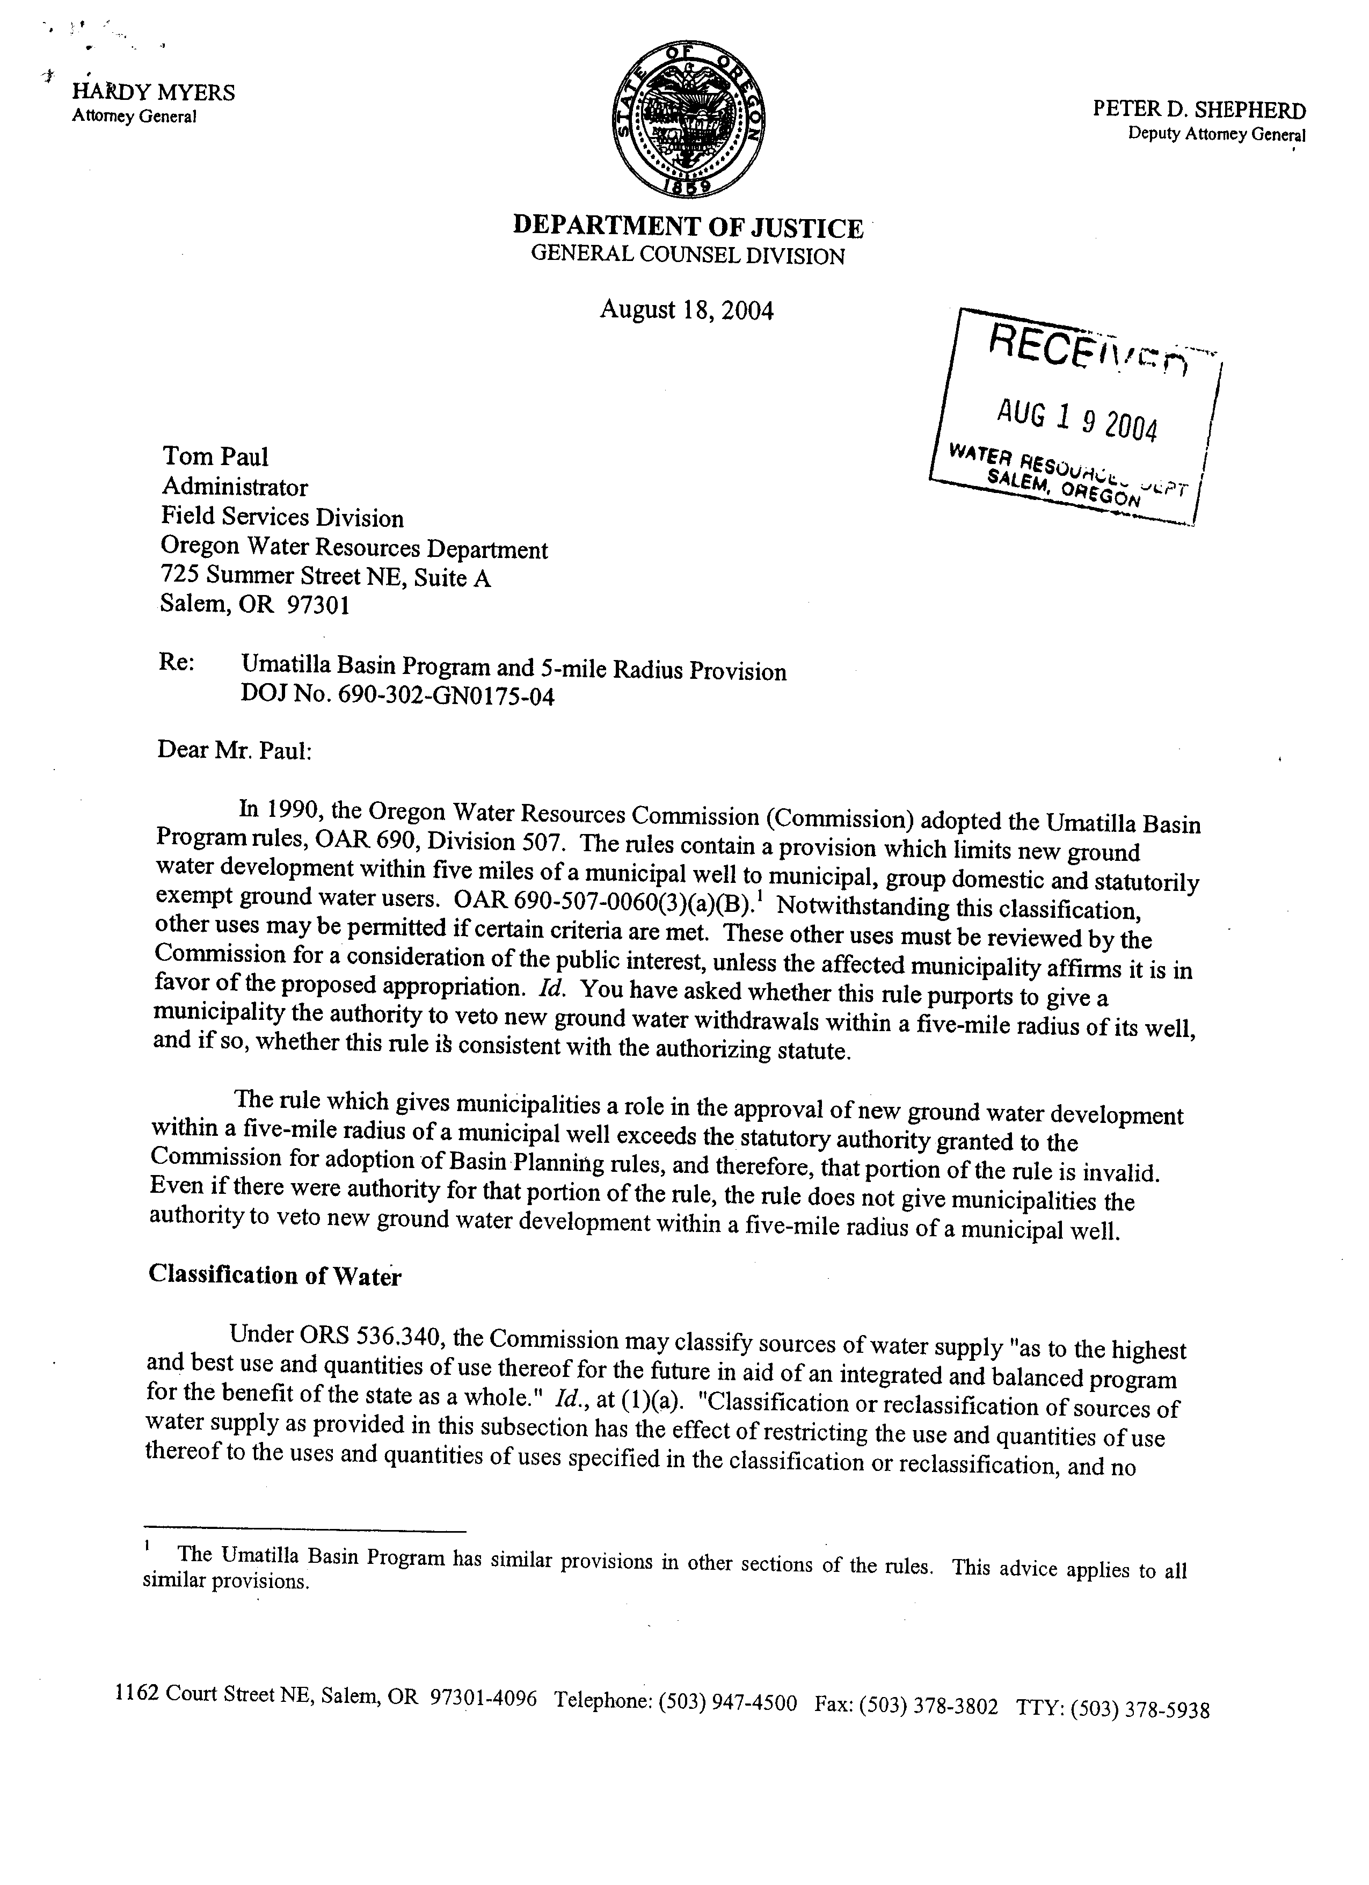
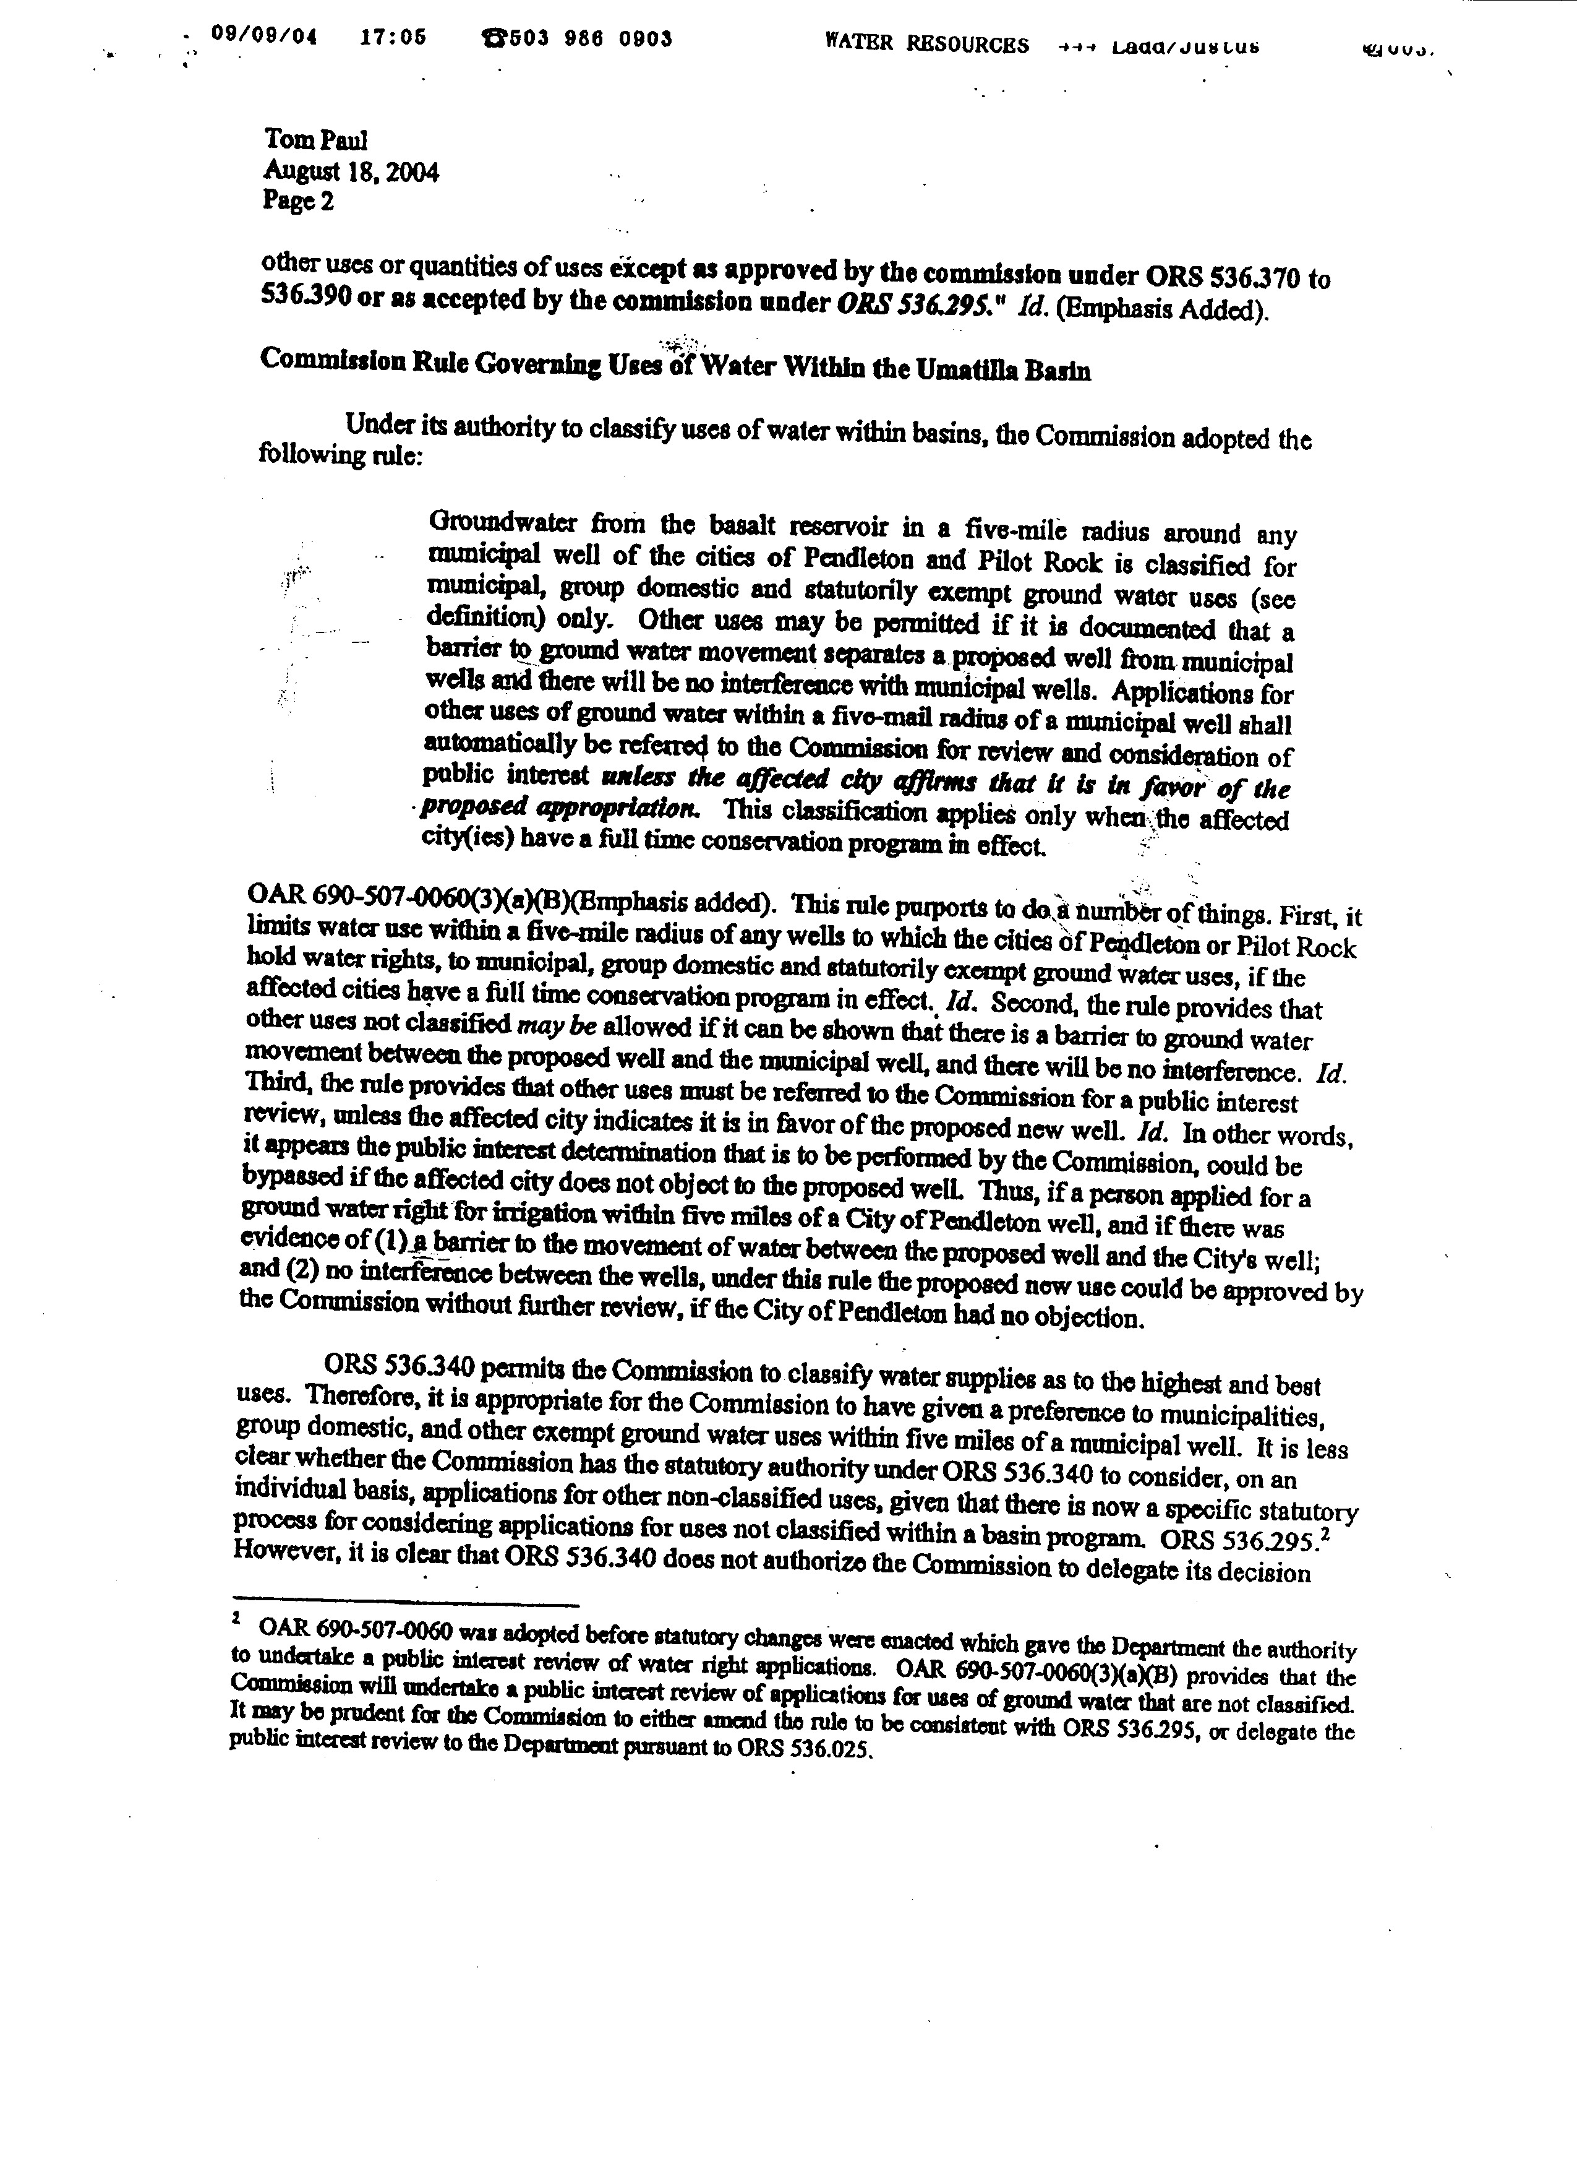

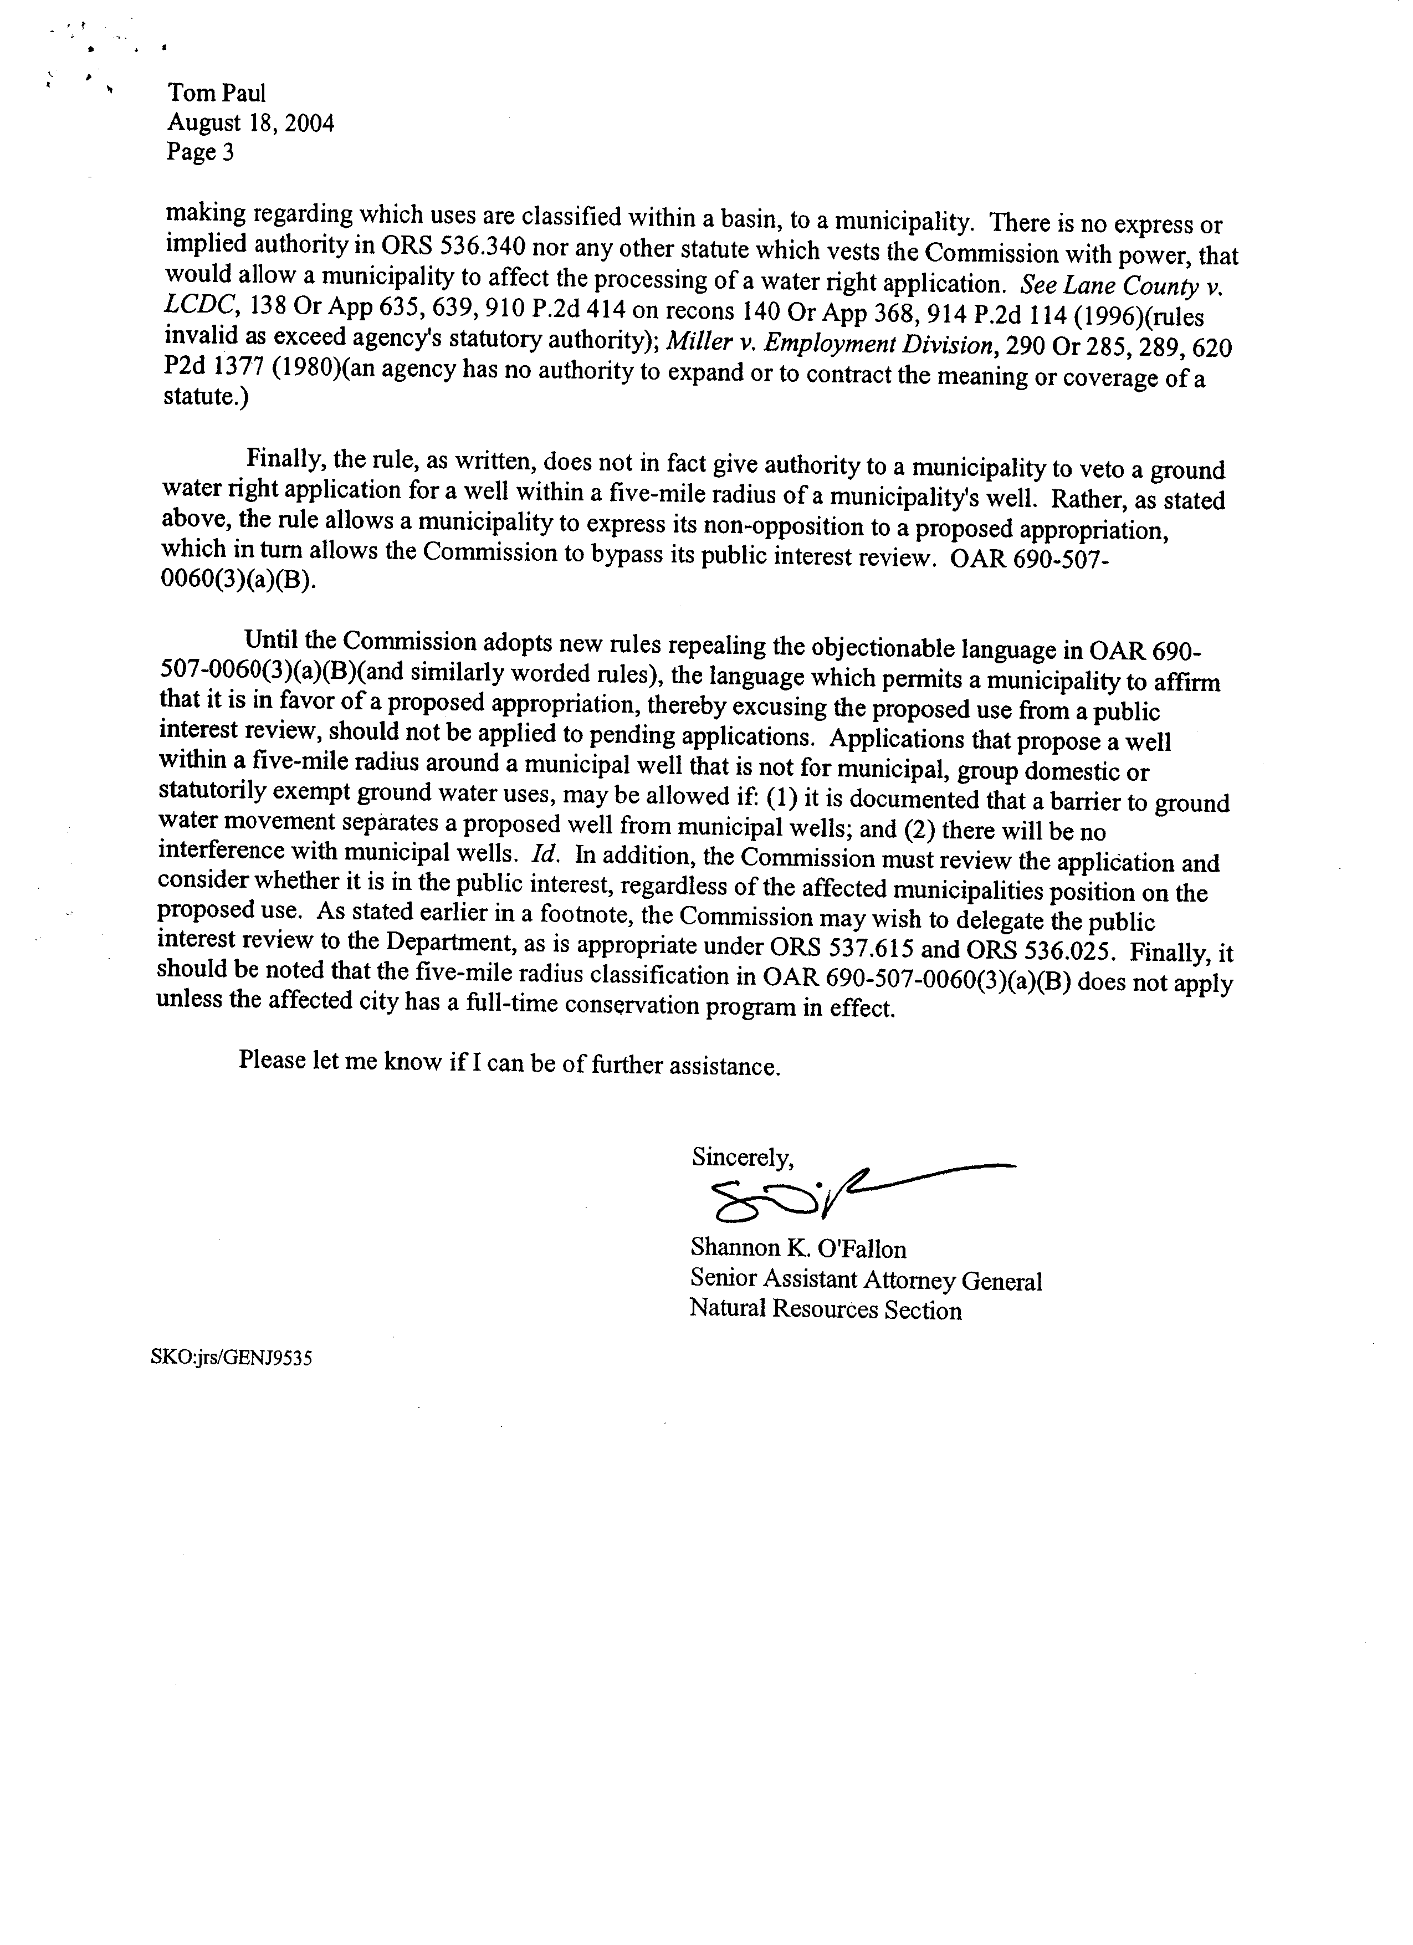

Attachment 4

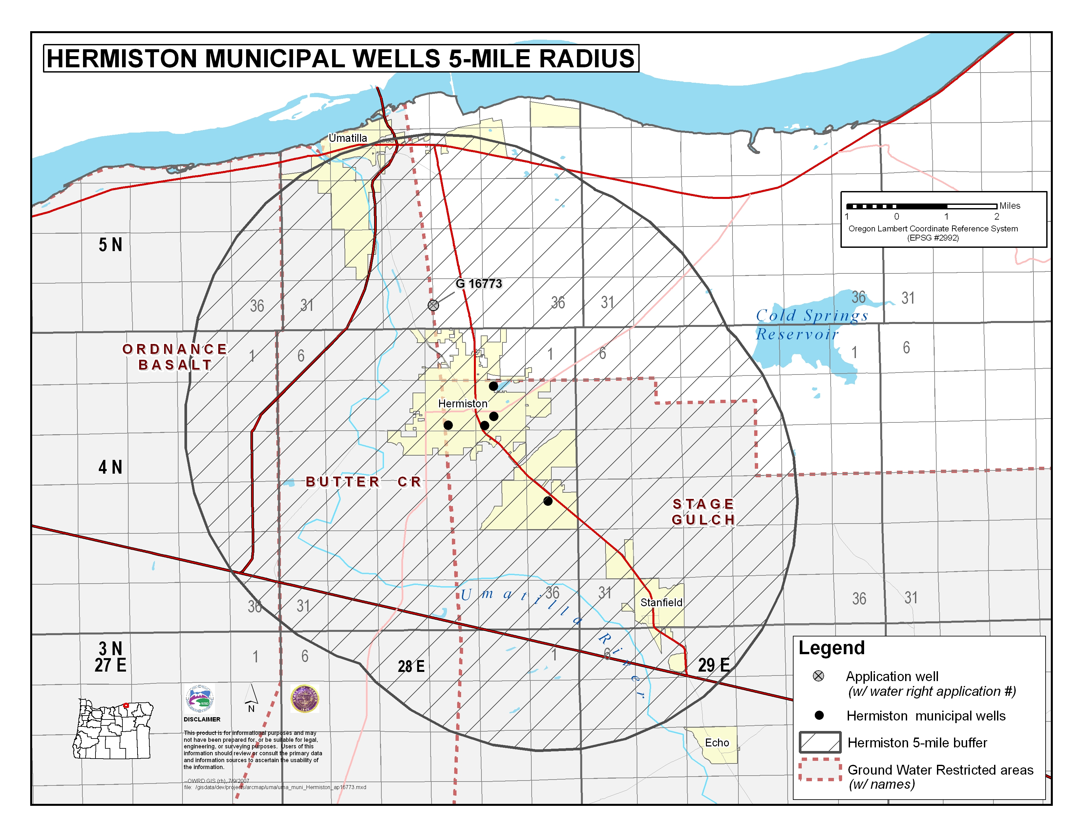

Attachment 5
