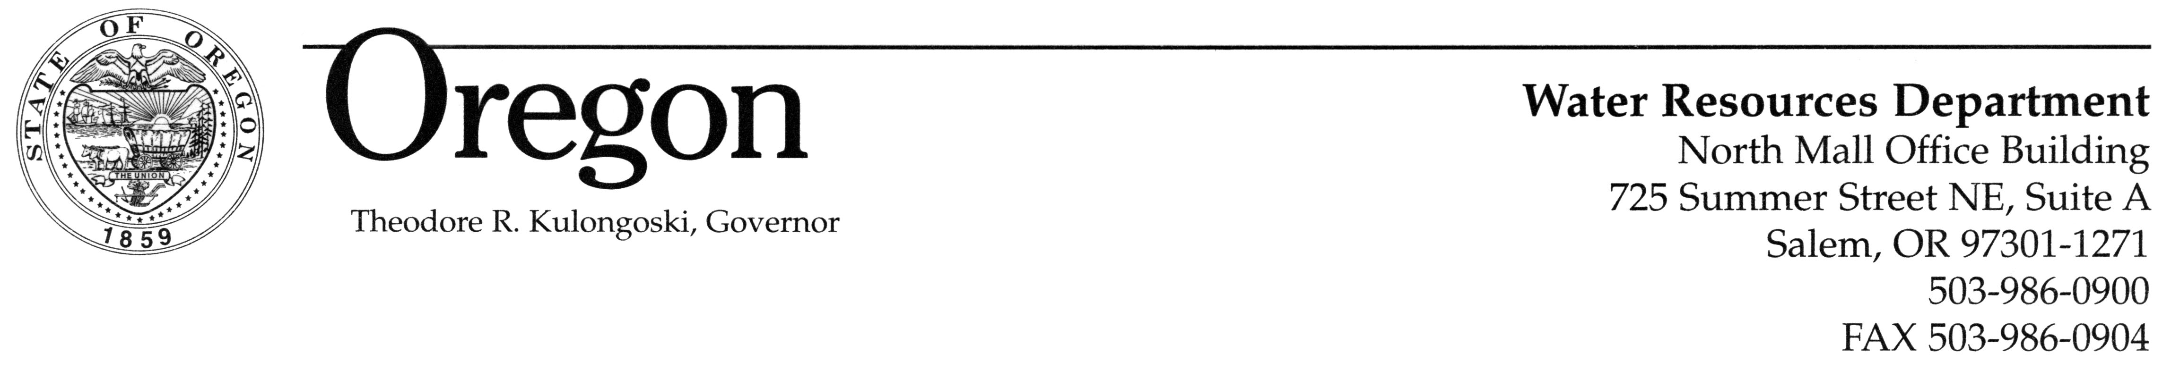

MEMORANDUM

TO: Water Resources Commission

FROM: Jerry Rodgers, Administrator
Technical Services Division

SUBJECT: Agenda Item H, August 30, 2007
Water Resources Commission Meeting

Update on Rulemaking on Special Area Well Construction Standards, OAR Chapter 690, Division 200

- Issue Statement

The Department is proposing to establish special area well construction standards for the Petes Mountain Area, in Clackamas County. The Department initiated rulemaking in an effort to ensure that accurate water level data can be obtained from wells in the area. This report is a progress update on the rulemaking process.

- Background

The Department has been contacted by members of the public expressing concerns about the ground water supply in the Petes Mountain Area. The Department has often been unable to obtain reliable data about the water resource in the area because of difficulty measuring water levels in wells. This is due to a combination of depth to water and pump installation practices that limit measurement probe access down wells. The Water Resources Department initiated the rulemaking process to address this water level measurement issue.

The Department was also contacted by the Petes Mountain Water Company and by the Petes Mountain Homeowners Association. Both groups are concerned that the water table may be declining due to current demands and that declines may increase due to potential new development associated with Measure 37 claims. The Homeowners Association and Petes Mountain Water Company are aware that special area well construction standards may be established.

Under the Commission authority to adopt rules to ensure the safe development of the ground water resource (ORS 537.780), the Department developed proposed rules establishing special area well construction standards. The proposed rules (Attachment 1) require all new, altered, deepened or converted wells constructed in the Petes Mountain Area to have a ¾ inch diameter dedicated measuring tube, and all new wells to have at least an eight inch diameter well casing.

Notice of the rulemaking was published in the Oregon Bulletin and provided to interested parties on July 2, 2007. In addition to the opportunity to provide written comment, a public rulemaking hearing was held in Canby on July 23, 2007. The hearing offered landowners and the public the opportunity to provide additional information to the Department about the proposed rules. Approximately 15 people attended. Seven individuals presented verbal testimony.

On July 27, 2007, staff met with the Commission’s Ground Water Advisory Committee (GWAC), which advises the Commission on rules for the development and protection of ground water (ORS 536.090). After lengthy discussion among committee members, GWAC’s advice to the Commission was to not move forward with the hearing draft of the rules. GWAC also recommended that the Department work with the Driller’s Technical Committee on specifications for the measuring tube.

The public comment period closed on August 1, 2007. The comments primarily focused on three main issues: 1) responsibility for installation of the measuring tube; 2) casing size in new construction; and 3) specifications for materials and sizing of the measuring tube. The Department is evaluating these comments and will be working with the Driller’s Technical Committee to resolve some of these concerns.

- Summary

This is an informational report and no Commission action is necessary. The Department is in the process of evaluating the comments received and will provide a recommendation to the Commission at the November meeting.

Juno Pandian
(503) 986-0852

